Variant Management Sample
Smoke Test
(Variability Items)



Aras Corporation
© 2002 Aras Corporation. All rights reserved

Aras Corporation
300 Brickstone Square
Suite 700
Andover, MA 01810

Phone: 978-794-7643
Fax: 978-794-9826

E-mail: info@aras-corp.com
Website: http://www.aras-corp.com

Notice of Rights
All rights reserved. Aras Corporation (Aras) owns this document. No part of this document may be reproduced or transmitted in any form by any means, electronic, mechanical, photocopying, recording, or otherwise, without the prior written permission of Innovator and other Aras product names and logos are trademarks of Aras Corporation.

Notice of Liability
The information contained in this document is distributed on an “As Is” basis, without warranty. While every precaution has been taken in the preparation of this document, Aras shall have no liability to any person or entity with respect to any loss or damage caused or alleged to be caused directly or indirectly by the information contained in this document or by the software or hardware products described in it.

NAME | Description of update | Date Updated
Olena Zaporozhets | Initial Creation according to Aras Innovator 12.0 - Variant Management Sample Application.pdf | 03/02/2020
Anastasia Bakshinova | Update according to Aras Innovator 12.0 - Variant Management Sample Application.pdf | 04/04/2020
Olena Zaporozhets | Update according to Aras Innovator 12.0 - Variant Management Sample Application.pdf | 04/07/2020
Olena Zaporozhets | Update according | 11/09/2020

Table of Contents

1 Send Us Your Comments 4
2 Overview 5
3 Prerequisites 6
3.1 Server Machine Setup 6
3.2 Client Machine Setup 6
3.3 Make sure notifications about every scripts error enabled in your browser 6
3.4 Test Setup 6
4 Functional Tests 8
4.1 Variability Item 8
4.2 View the Variability Items in the Variability Structure 10
4.3 Table Rule Editor 12
4.4 Text Rule Editor 14
4.5 Variant Tree 16
4.6 Variability Validations 19

Send Us Your Comments
Aras Corporation welcomes your comments and suggestions on the quality and usefulness of this document. Your input is an important part of the information used for future revisions.
- Did you find any errors?
- Is the information clearly presented?
- Do you need more information? If so, where and what level of detail?
- Are the examples correct? Do you need more examples?
- What features did you like most?

If you find any errors or have any other suggestions for improvement, indicate the document title, and the chapter, section, and page number (if available).

You can send comments to us in the following ways:
- Email:
Support@aras.com
Subject: Aras Innovator Documentation
Or,
- Postal service:
Aras Corporation
300 Brickstone Square
Suite 700
Andover, MA 01810
Attention: Aras Innovator Documentation
Or,
- FAX:
978-794-9826
Attn: Aras Innovator Documentation

If you would like a reply, provide your name, email address, address, and telephone number.

If you have usage issues with the software, visit http://www.aras.com/support/

Overview
This Smoke Test document will go through and validate that the basic functionality of Variant Management Application.

Prerequisites
There are a few prerequisites that need to be done before the test plan can be executed.

Server Machine Setup
- Innovator needs to be set up (refer to the Innovator install guide)
- Vaults need to be set up and functional (refer to the Innovator install guide)
- Your database needs to be a FRESH database with all the correct patches applied to it
- You should have the previous version of Innovator installed on the system as well. (This helps catch installer errors.)

Client Machine Setup
- Clean up cache
  - Delete Browser temporary files
  - Delete assembly files
- If Browser Firefox delete Innovator XPI extension from list of Firefox Add-ons

Make sure notifications about every scripts error enabled in your browser

Test Setup
- Download VM build.
- Launch Aras Update.
  - Go to Local tab in the sidebar.
  - Click on “Add package reference”
  - Select the VM Sample Application installation package –> Click OK.
    - Confirm that VM Sample is displayed in the list of packages.
  - Click on Install
- Select the components you want to install
Aras Innovator Code Tree Updates
Aras Innovator Database Updates
Sample Data Actions
- Click Next
- Choose Detailed Logging -> Click Next
- Enter the required parameters for the target Aras Innovator instance
  - Click on Browse for Install Path field.
  - Select the path of the necessary instance to the Innovator folder.
- Expand Aras Innovator Database Updates.
  - Fill in Server URL, Database.
  - Username: root.
  - Password: innovator.
- Click on Install.
  - Confirm that VM sample successfully installed.
- When the package finishes installing, close Aras Update
- Log into Innovator as admin.
- In the main menu, select Actions > Load Variant Management Sample Data.
- When prompted, enter the file path of the Variant Management Sample Application package.
Example: If the Variant Management Sample Application package was downloaded and unzipped to C:\VMSample, enter C:\VMSample.
- Running the Load Variant Management Sample Data action will overwrite any variant sample data loaded by a previous execution. Click Ok in the warning prompt to continue loading.
- After the load completes, navigate to Variant Management in the TOC to confirm that instances of Features, Options, Breakdown Items, Variability Items, and Variable Components have been added.

Functional Tests

Variability Item
Test # | VM-VI-001
Purpose: | To test create and edit Variability Items  Variability Item - a node in configurable structure.
Test Setup | - Pass Test Setup from 3.4  - Use the nash.aspx and apply AML  - Login as admin / innovator.  - Apply VM_Structure.xml.
- Login to Innovator as admin

- Create Variability Item
  - Go to Variant Management section in Navigation panel -> Variability Items
    - Confirm that Variability Items menu appears
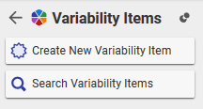
  - Click Create New Variability Item
    - Confirm that following form appears
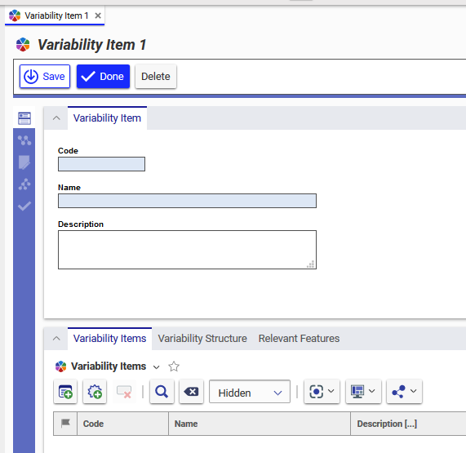

    - Confirm that there is the icon near keyed name of Variability Item
    - Confirm that there is the icon near “Variability Items” title if Variability Item
    - Confirm that there is the icon near “Variability Items” title in “Variability Items” tab
  - Type
Code: TVI04
Name: TestVI4
  - Click Done -> Close the Item

- Go to Variant Management section in Navigation panel -> Variability Items -> Search Variability Items
  - Confirm that TestVI1, TestVI2, TestVI3 and TestVI4 are displayed in main grid

- Edit Variability Item
  - Select TestVI3 from main grid -> RMB –> Open -> Edit
  - Go to Variability Items on Relationship Tab
  - Click Add Variability Items -> select TestVI4 -> OK
    - Confirm that TestVI4 appeared in Variability Items Tab
  - Click New Variability Item 
  - Type
Code: TVI07
Name: TestVI7
  - Click Save
  - Update Sequence. Sequence 21 for TVI07 and Sequence 32 for TVI04
  - Done -> Close TestVI3 item

- View multi-level sub-structure:
  - Select TestVI1 in main grid tab -> open it
  - Go to Variability Structure tab in Relationship Tab
    - Confirm that multi-level Variability Item Structure is displayed
    - Confirm that TestVI2, TestVI3, TestVI4 and TestVI7 are displayed with them features and options.
    - Confirm that there are icons for Variability Items, Features and Options in Variability Structure tab in Variability Item
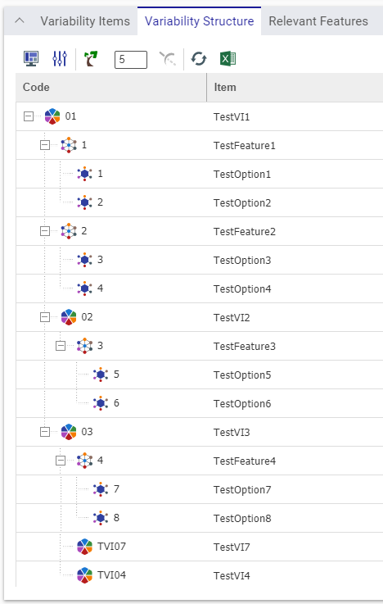
  - Click for TestVI3 item
    - Confirm that the node was collapsed
  - Click for TestVI3 item
    - Confirm that the node was expanded
  - Close TestVI1 item

- Add Feature to Relevant Features tab
  - Go Variability Items tab -> Select TestVI3 -> Open it -> Edit
  - Go to Relevant Features tab for TestVI3
  - Click Add Features -> select TestFeature2 -> OK
    - Confirm that TestFeature2 appeared in Relevant Features Tab
  - Click New Feature
  - Enter 7 in Code and New in Name fields
  - Click Save
  - Go to Variability Structure tab in Relationship Tab
    - Confirm that New Feature is displayed in Variability Structure
  - Close TestVI3

- Delete Variability Item
  - Go Variability Items tab -> Select TestVI3 -> Open it -> Edit
  - Go to Variability Items tab for TestVI3
  - Select TestVI4 -> Click Delete Variability Structure 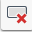
  - Click Save for TestVI3
    - Confirm that TestVI4 was removed
  - Done -> close the Item

  - Click on Search in Variability Items tab
  - Select TestVI4 in main grid -> RMB –> More -> Delete
  - Click Delete in dialog
    - Confirm that TestVI4 was removed successfully.

View the Variability Items in the Variability Structure
Test # | VM-VI-002
Purpose:
Test Setup | Pass Test Setup from 3.4
- Log into Innovator as admin

- Go to Variant Management section in Navigation panel -> Variability Items -> Open Bicycle
- Go to Variability Structure tab in Relationship Tab
- Click the Display Settings icon . The Display Settings dialog appears
- Click on the Toggle visibility icon to turn off visibility for Features, as shown in the following figure:
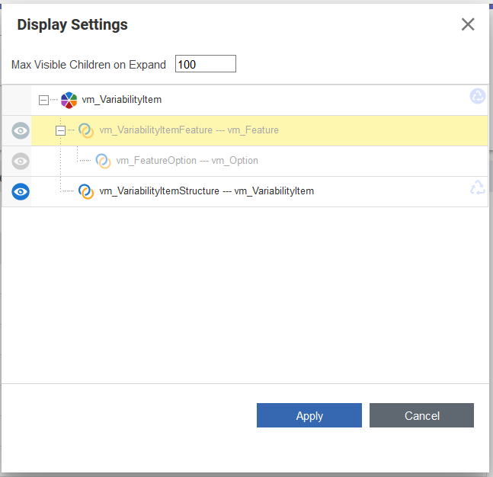

- Click Apply. Now the Variability Structure only displays the Variability Items. The Features and Options are hidden
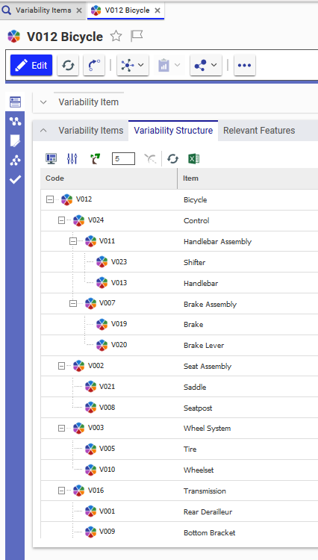
- Close Bicycle item

Table Rule Editor
Test # | VM-VI-003
Purpose: | to create a Rule  Rule is used for specifying which options from various families can or cannot go together.
Test Setup | Pass Test Setup from 3.4
- Log into Innovator as admin

- Go to Variant Management section in Navigation panel -> Variability Items -> Open Frame -> Edit
- Using of “Build Table on Rules” action
  - Go to Table Rule Editor Tab on Sidebar
  - Go to Rules List -> RMB on the first rule with “00000007” Code
  - Select “Build Table on Rules” in context menu

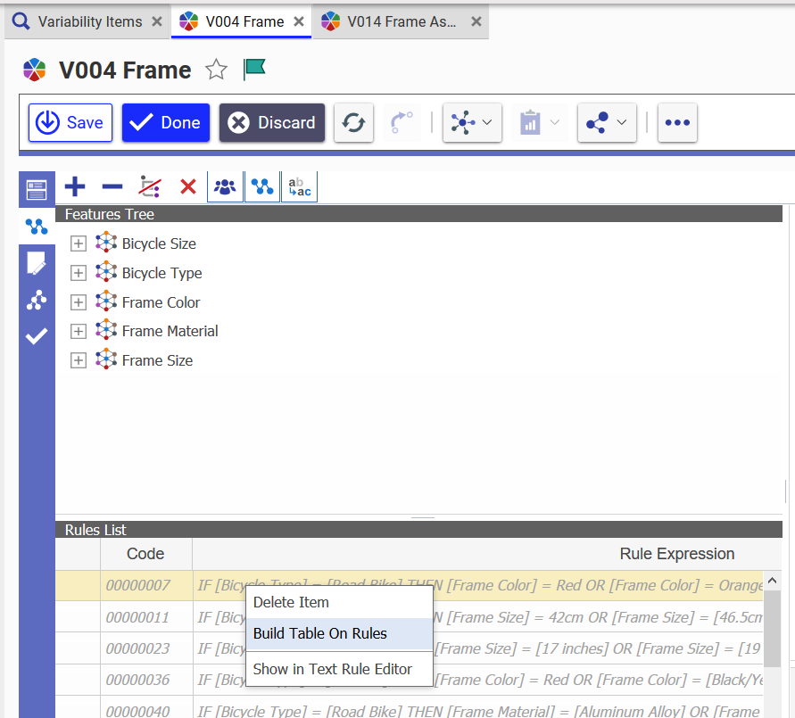

    - Confirm that table was created
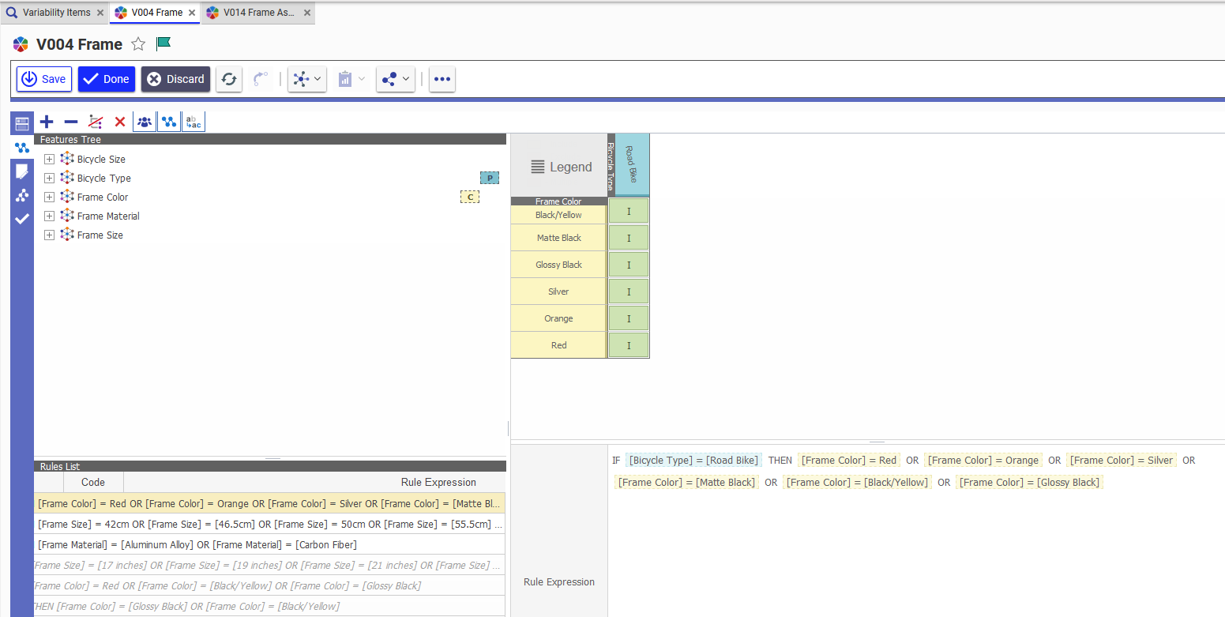

- Create Rules:

  - Uncheck all Constrained and Principal Groups
  - Click on Expand all
  - Choose Silver (in Frame Color) as Principal Group
  - Choose Frame Material as Constrained Group
  - RMB Click - Include at the intersection Silver and Aluminum Alloy
    - Confirm that expression is shows in Rule Expression section
IF [Frame Color] = Silver THEN [Frame Material] = [Aluminum Alloy]

  - RMB Click - Exclude at the intersection Silver and Stainless Steel
    - Confirm that expression is shows in Rule Expression section
IF [Frame Color] = Silver THEN NOT ([Frame Material] = [Stainless Steel])

  - Click Save and close Frame

  - DB click on Frame on main grid
  - Go to Table Rule Editor Tab
    - Confirm that all changes were saved.
- View Rules in Text Rules Editor:
  - Go to Rules List
  - Select any Rules
  - RMB Click –> Show in Text Rule Editor
    - Confirm that Tab Text Rule editor open and all Rules are displayed
  - Close Frame
- Remove Rules:
  - DB click on Frame in main grid -> Edit
  - Go to Table Rule Editor
  - Select new rules in Rules List Grid
IF [Frame Color] = Silver THEN [Frame Material] = [Aluminum Alloy]

  - RMB Click - Delete Item
    - Confirm that all Rules was marked icon
  - Select new rules in Rules List Grid
IF [Frame Color] = Silver THEN NOT ([Frame Material] = [Stainless Steel])

  - Go to toolbar of Text Editor- Delete Item
  - Click Done
    - Confirm that all Rules was removed successfully
  - Close Frame

Text Rule Editor
Test # | VM-VI-004
Purpose: | to create/edit Rules
Test Setup | Pass Test Setup from 3.4
- Log into Innovator as admin

- Go to Variant Management section in Navigation panel -> Variability Items -> Open Frame -> Edit
- Go to Text Rule Editor Tab
    - Confirm that Text editor button on the toolbar has new image 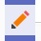 of icon
- Edit Rules:
  - Select the first rule with “00000004” Code
  - Edit Rule conditions. New expression:
IF [Bicycle Type] = [Road Bike] AND [Bicycle Size] = Medium THEN [Frame Size] = [14 inches]
  - Click Apply Changes
  - Click Save
    - Confirm that changes were saved successfully
  - Select the first rule with “00000004” Code
  - Edit Rule conditions. New expression:
IF [Bicycle Type] = [Road Bike] THEN [Frame Size] = [14 inches]
  - Click the Reset Changes icon to reset your changes
  - Click View XML Expression
    - Confirm that XML shown as
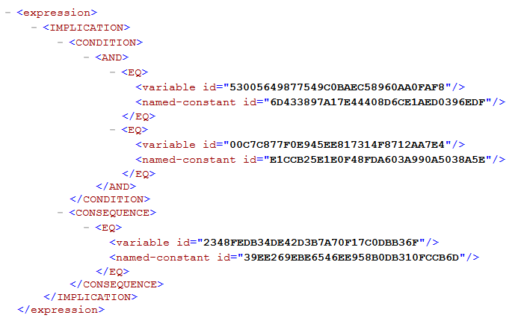
  - Click View XML Expression again
  - Edit Rule conditions. New expression:
IF [Bicycle Type] = [Road Bike] AND [Bicycle Size] = Medium THEN [Frame Size] = 50cm
  - Click Apply Changes
  - Click Save

- Create new Rules:
  - Click Create New in Text Rule Editor Tab
    - Confirm that New empty Rule appeared
    - Confirm that Tabs (Form, Variant Tree and Validation) are disabled
  - Enter Rule conditions:
IF [Bicycle Type]=[Fat Bike] THEN NOT ([Frame Color]=Red)
    - Confirm that icon was disappeared
  - Click Save
  - Click Create New
  - Enter Rule conditions:
IF [Bicycle Type]
    - Confirm that only = in drop-down List
  - Enter manually >=
    - Confirm that the error appears, and this operator doesn’t support
  - Delete
IF [Bicycle Type] >=
  - Enter Rule:
IF [Frame Material]=[Stainless Steel] THEN NOT ([Frame Color]=[Matte Black])
  - Click Save

- Filter settings
  - Click on Set filter button 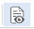 in Text Rule Editor Tab
  - Expand all features
    - Confirm that there are icons for Features and Options in Filter settings dialog in Text Rule Editor sidebar tab of Variability Item
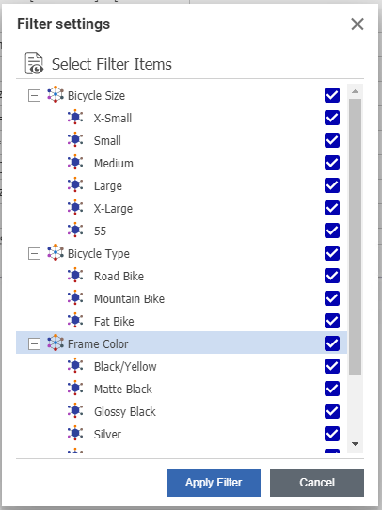
  - Click Cancel

- Delete Rule:
  - Select new rule
IF [Bicycle Type]=[Fat Bike] THEN NOT ([Frame Color]=Red)
  - Click icon
    - Confirm that Rule was marked icon
  - Delete another rule
IF [Frame Material]=[Stainless Steel] THEN NOT ([Frame Color]=[Matte Black])

  - Click Save
    - Verify that the selected Rules were disappeared
  - Click Done - > close item

Variant Tree
Test#: | VM-VI-004
Purpose: | To test Variant tree ant its possibility
Setup | Pass Test Setup from 3.4
- Log into Innovator as admin

- Go to Variant Management section in Navigation panel -> Variability Items -> Open Tire -> Edit
- Go to the Variant Tree tab
    - Confirm that the Variant Tree Settings dialog box appears
- Expand all features
    - Confirm that the Features and Options available for the current Variability Item is displayed
- Select Tire Size Feature -> RMB
    - Confirm that user can select either Select All or Unselect All from the context menu.
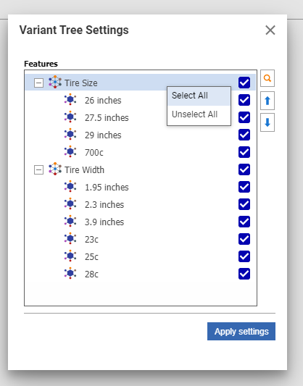
- Uncheck Tire Size feature
- Check Tire Size feature again
    - Confirm that user can Select/Unselect desired Features and Options
- Click button Down for Tire Size feature and Up for 23c option
    - Confirm that order of the Features or Options is changed
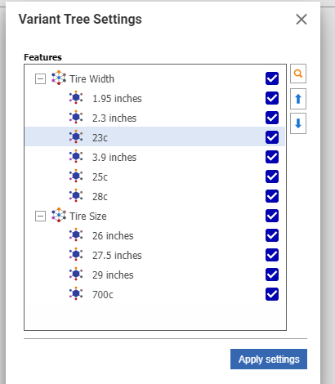
- Click Apply settings button
    - Confirm that the Variant Tree and the number of valid combination counts are displayed based on the selections in Variant Tree Settings.
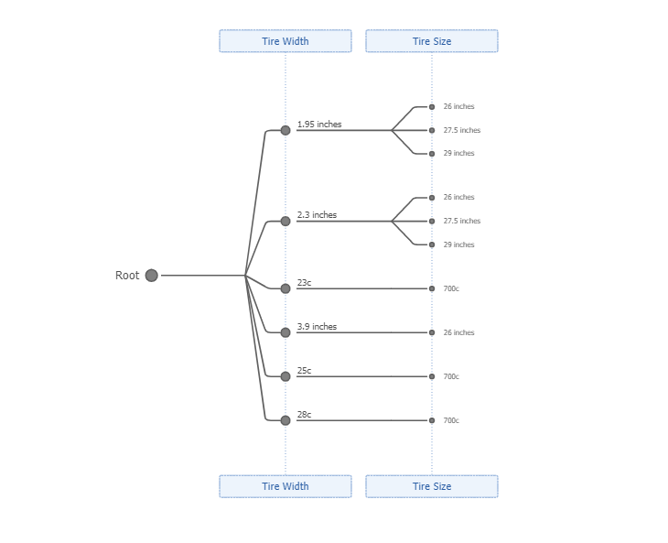
- Use to zoom in and zoom out.
- Use to increase or decrease spacing between tree branches.
- Click for 1.95 inches in the Tree View to collapse and re-expand a branch.
    - Confirm that the “1.95 inches” branch has been collapsed.
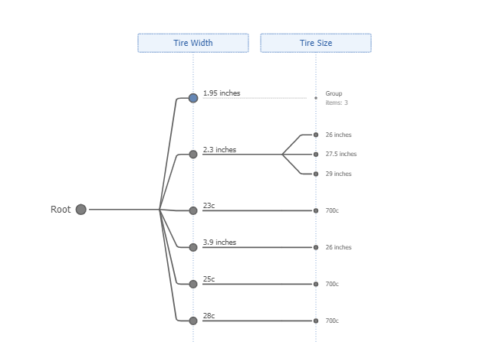

- Click the Export to html iconto create an HTML version of the Variant Tree using the specified Variant Settings.
    - Confirm that the HTML file is created and downloaded to the default download location
- Open Variant Tree.html
    - Confirm that variant tree displayed correctly with all Features and Options in html document
    - Confirm that HTML has the same features as the Variant Tree, such as scale, spacing, collapse/expand branch
- Close Variant Tree.html
- Click the Change Settings icon in Tire Variability item.
    - Confirm that the Variant Tree Settings dialog is displayed and select/deselect different features and options.

Variability Validations
Test # | VM-VI-005
Purpose: | to Validate a Generic Structure and Verify Which Options are not available
Test Setup | Pass Test Setup from 3.4
- Log into Innovator as admin

- Go to Variant Management section in Navigation panel -> Variability Items -> Open Tire -> Edit
- Go to the Validation tab
    - Confirm that following appears
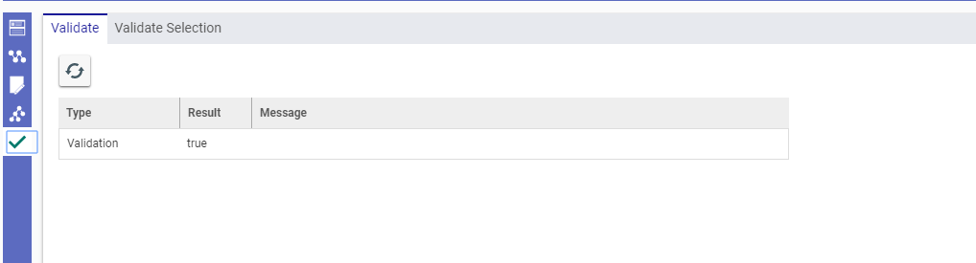
- Go to the Validate Selection tab
    - Confirm that the relevant features and options for the Variability Item and its structure is displayed
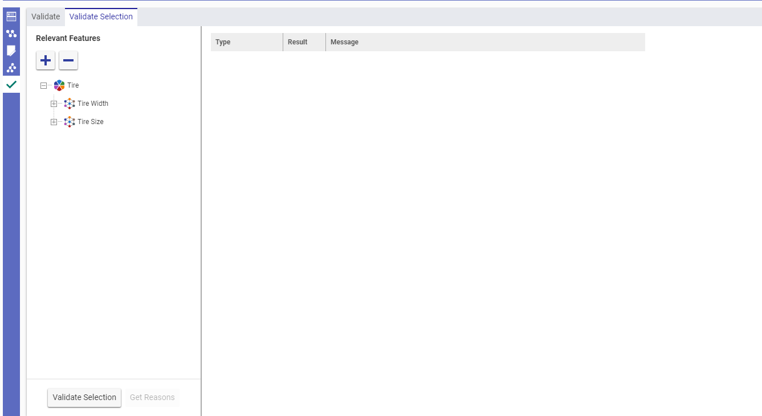
    - Confirm that Get Reason button is not activated

- Click Expand All
- Select 1.95 inches for Tire Width and 26 inches for Tire Size
- Click Validate Selection button
    - Confirm that Validate selection tab has such view
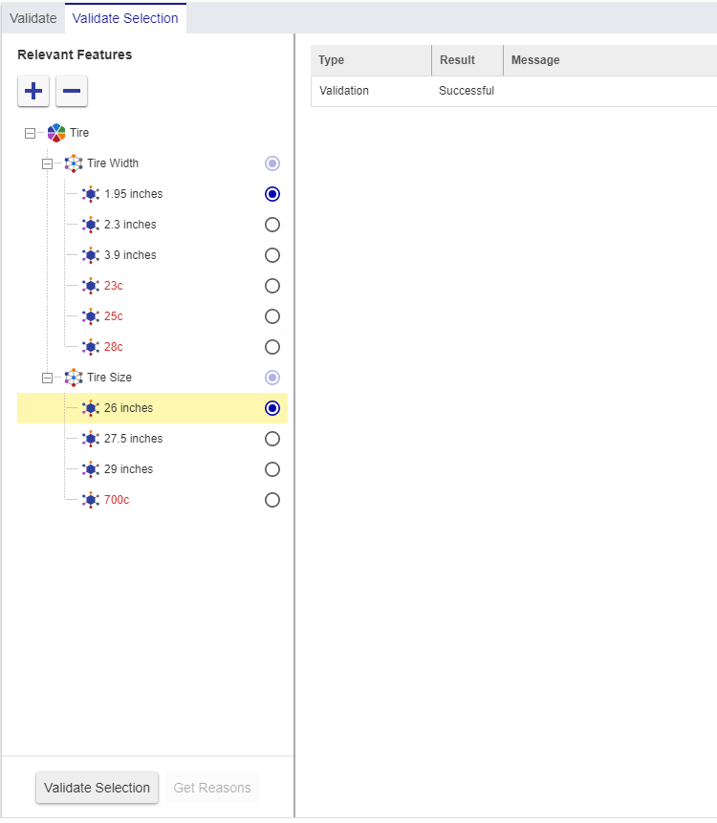
    - Confirm that Get Reason button is not activated

- Select 700c for Tire Size
- Click Validate Selection button
    - Confirm that following appears
    - Confirm that Get Reasons button is activated
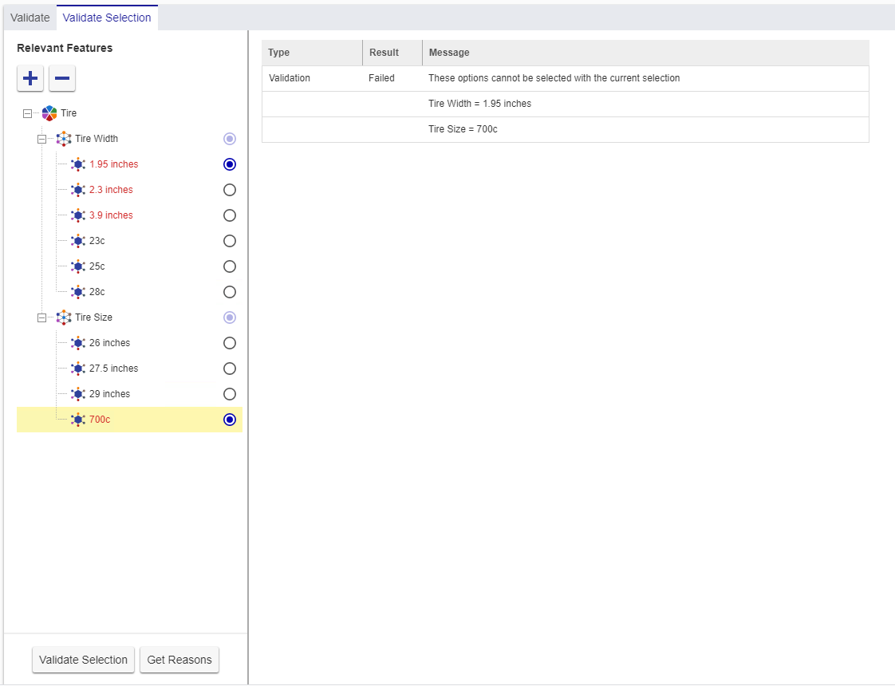
- Click Get Reason button
    - Confirm that following diagram appears
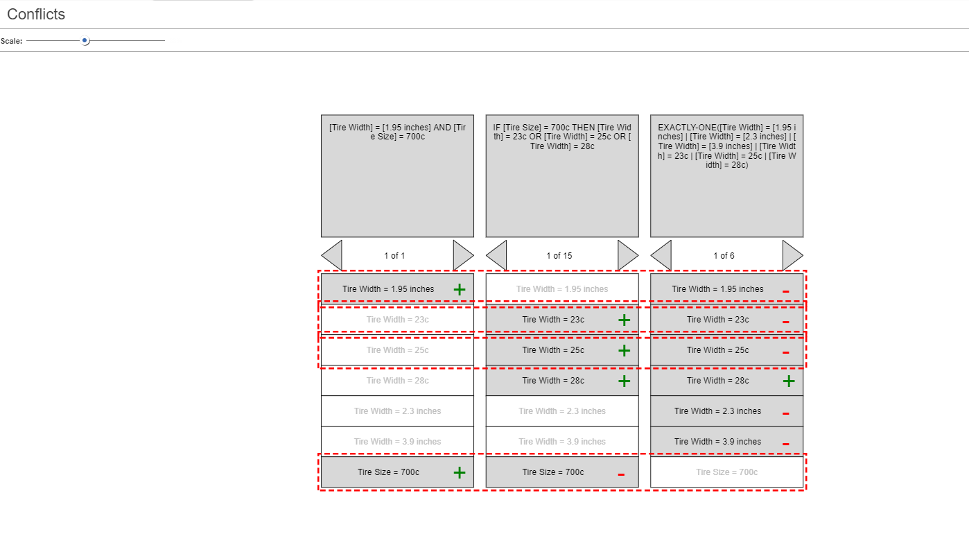
  - Click on Next Variant  in the third Collumn
    - Confirm that Tire Width = 1.95 inches becomes marked and that this row don’t highlighted in red anymore
    - Confirm that with any selected Variants in columns always at least one row is highlighted in red
- Close Item

